Synopsis
On
Git for Embeddings: Version Control and Incremental Management System for Vector Embeddings

Group ID: TYAIA116
Team Details
Enrolment No. | Name of Student | Class
[Enrolment No.] | Adwait Tagalpallewar | TYAIA-1
[Enrolment No.] | Sagar Shahgond | TYAIA-1
[Enrolment No.] | Archit Bankey | TYAIA-2
ADT24SOCB0756 | Parth Verma | TYCC-1

Under the Guidance of
Prof. Dr. Nagesh Jadhav

Department of Computer Science & Engineering
MIT School of Computing
Sem- 5 | A. Y. 2026-27
1. Title of the Project
Git for Embeddings: Version Control and Incremental Management System for Vector Embeddings
2. Abstract
Modern AI systems such as semantic search engines, recommendation systems, and Retrieval-Augmented Generation (RAG) pipelines rely heavily on embeddings — numerical vector representations of text, images, or documents. Embeddings are not static: they change whenever source documents, preprocessing logic, chunking strategy, metadata, or the embedding model itself is updated. Existing approaches typically regenerate entire embedding collections whenever any change occurs, which is computationally expensive, time-consuming, and difficult to reproduce at scale.
This project proposes EmbeddingVC, a Git-inspired version control system for embeddings that tracks changes at the document and chunk level using content and configuration hashing, and updates only the affected vectors while safely reusing the rest. The system distinguishes between changes that permit incremental reuse (data or preprocessing changes with the same embedding model) and changes that require full regeneration (a change of embedding model, since vector spaces from different models are generally not directly comparable). It maintains version history with complete provenance to support rollback, comparison, and reproducibility, and exposes this through a simple interface. The expected outcome is a functional prototype that measurably reduces recomputation cost compared to full regeneration while preserving retrieval quality and reproducibility.
3. Introduction / Background
Embeddings are widely used in modern AI applications to represent text, images, and other data as numerical vectors, enabling semantic similarity search and intelligent retrieval. These vectors are stored and indexed in vector databases such as ChromaDB, FAISS, Pinecone, Weaviate, Milvus, and Qdrant, and they underpin RAG pipelines, semantic search engines, and recommendation systems.
However, embeddings drift out of date whenever the underlying documents, chunking parameters, preprocessing steps, metadata, or the embedding model change. Unlike source code, embedding datasets generally have no standardized, Git-like mechanism to track such changes, identify which vectors have become stale, or reproduce a prior state of the dataset. In practice, teams either regenerate entire collections, overwrite existing vectors, spin up separate database collections, or build custom internal scripts — all of which are inefficient, error-prone, and hard to audit or roll back.
4. Problem Definition
Modern AI systems such as RAG, semantic search, and vector databases rely on embeddings. When source documents, preprocessing, chunking, or embedding models change, existing embeddings become outdated. Current systems often regenerate the entire embedding collection, leading to high computational cost and longer processing time. Therefore, a Git-inspired version control system is needed to efficiently track embedding changes, reuse valid embeddings, and regenerate only the affected vectors.
5. Objectives
a) To design a Git-inspired version control system for embedding datasets.
b) To detect changes in source documents, chunks, and metadata using content hashing.
c) To classify embeddings as reusable, stale, added, or deleted through hashing and configuration tracking.
d) To implement incremental regeneration so that only affected embeddings are recomputed.
e) To maintain version history that supports commit, rollback, and comparison operations.
f) To evaluate time, storage, and retrieval-quality trade-offs against full regeneration.
6. Scope of the Project
The project focuses on version-controlling embeddings for text-based AI systems, covering document, chunk, and configuration-level change tracking and incremental updates. It does not involve training new embedding models. A change of embedding model is treated as a major version change that requires regeneration; investigating whether embeddings from different model versions can be aligned or mapped into a common space is treated as future work rather than a core deliverable.
7. Proposed System
EmbeddingVC introduces a Git-inspired version control framework for AI embeddings. The system tracks document changes, identifies stale embeddings using content and configuration hashes, incrementally regenerates only the affected vectors, and maintains version history with complete provenance. Instead of rebuilding the entire vector database after every modification, EmbeddingVC updates only the changed embeddings, reducing computational cost while improving reproducibility and retrieval consistency.
In practice, input documents are cleaned, normalized, and split into chunks. Each chunk and the active configuration (model, chunk size, overlap, preprocessing settings) are hashed to enable change detection. Comparing the current hashes against the previous committed version classifies every chunk as unchanged (reusable), modified (regenerate), newly added (generate), or deleted (remove). Only the affected chunks are passed through the embedding generation module; unchanged embeddings are reused directly from storage. Updated vectors are written to a vector database (ChromaDB / FAISS), and the resulting state is committed to the EmbeddingVC version-control layer, which records full provenance and supports rollback and comparison between versions. The system prevents embeddings produced by incompatible models from being mixed within a collection.
System Architecture / Workflow Diagram
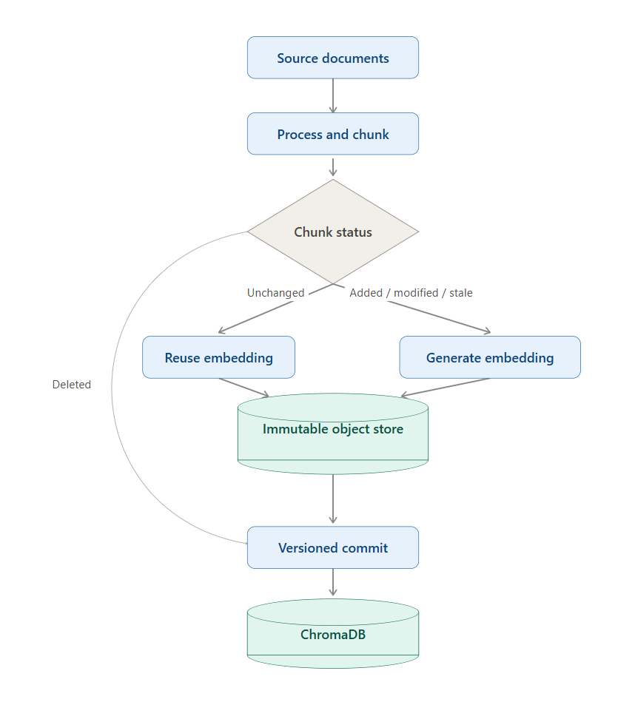
Fig. 1: EmbeddingVC change-detection and incremental-update pipeline
8. System Requirements
a. Hardware Requirements
1. Laptop/PC with minimum 4 GB RAM
2. Standard processor (Intel i3 or equivalent)
b. Software Requirements
Python, FastAPI or Flask, Streamlit (for UI), ChromaDB / FAISS (vector database), Sentence Transformers / embedding models, SHA-based hashing utilities, VS Code / GitHub.
9. Methodology / Implementation Plan (Project Tracker Sheet)
The project will follow an iterative development approach. The phases include:
1. Requirement analysis and system design
2. Document processing and chunking module development
3. Hashing and change-detection implementation
4. Embedding generation and vector database integration
5. Incremental update mechanism development
6. Version control layer: commit, rollback, and comparison
7. Benchmarking against full-regeneration baselines
8. Testing and evaluation
Techniques used include embeddings and vector similarity, SHA-based hashing for change detection, incremental computation, version-control concepts, and vector database indexing.
10. Expected Outcome
A functional prototype (EmbeddingVC) that efficiently manages embedding datasets using version-control principles — reducing unnecessary recomputation, enabling incremental updates, and ensuring reproducibility and consistency in embedding-based AI systems such as RAG pipelines and semantic search.

11. Applications / Use Cases
a) Retrieval-Augmented Generation (RAG) systems
b) Semantic search engines
c) Recommendation systems
d) Document retrieval systems
e) AI-powered knowledge bases
12. Future Enhancements / Future Scope
a) Support for multimodal embeddings (image, audio, video)
b) Cross-model embedding alignment and vector-space mapping techniques
c) Distributed and collaborative version control for large teams
d) Integration with managed cloud vector databases (Pinecone, Weaviate, Qdrant)
e) Automated semantic-drift measurement between embedding versions
f) Advanced visualization of embedding changes and version diffs
13. References
1) Reimers, N., & Gurevych, I. (2019). Sentence-BERT: Sentence Embeddings using Siamese BERT-Networks. Proceedings of EMNLP-IJCNLP.

2) Lewis, P., Perez, E., Piktus, A., Petroni, F., Karpukhin, V., Goyal, N., et al. (2020). Retrieval-Augmented Generation for Knowledge-Intensive NLP Tasks. Advances in Neural Information Processing Systems (NeurIPS).

3) Johnson, J., Douze, M., & Jégou, H. (2019). Billion-Scale Similarity Search with GPUs. IEEE Transactions on Big Data. (FAISS)

4) Chacon, S., & Straub, B. (2014). Pro Git. Apress. (Git Version Control Concepts)

5) Vaswani, A., Shazeer, N., Parmar, N., Uszkoreit, J., Jones, L., Gomez, A. N., Kaiser, Ł., & Polosukhin, I. (2017). Attention Is All You Need. Advances in Neural Information Processing Systems (NeurIPS).

6) Hu, W., Bansal, R., Cao, K., Rao, N., Subbian, K., & Leskovec, J. (2022). Learning Backward Compatible Embeddings. Proceedings of the 28th ACM SIGKDD Conference on Knowledge Discovery and Data Mining (KDD). :contentReference[oaicite:0]{index=0}

7) Shen, Y., Xiong, Y., Xia, W., & Soatto, S. (2020). Towards Backward-Compatible Representation Learning. Proceedings of the IEEE/CVF Conference on Computer Vision and Pattern Recognition (CVPR). :contentReference[oaicite:1]{index=1}

8) Meng, Q., Zhang, C., Xu, X., & Zhou, F. (2021). Learning Compatible Embeddings. Proceedings of the IEEE/CVF International Conference on Computer Vision (ICCV). :contentReference[oaicite:2]{index=2}

9) Chroma Team. (2023). ChromaDB Documentation. Chroma. (Vector Database Documentation)

10) Reimers, N., & Team. (2023). Sentence-Transformers Documentation. Hugging Face. (Official Documentation)

11) Alshami, M., et al. (2026). Efficient Vector Database Management in Retrieval-Augmented Generation Systems: A Selective Embedding Update Approach. Proceedings of the International Conference on Recent Advances in Electrical, Electronics, Ubiquitous Communication and Computational Intelligence (RAEEUCCI). :contentReference[oaicite:3]{index=3}

12) Anonymous. (2025). Drift-Adapter: A Practical Approach to Near Zero-Downtime Embedding Model Upgrades in Vector Databases. Proceedings of the 2025 Conference on Empirical Methods in Natural Language Processing (EMNLP).).

